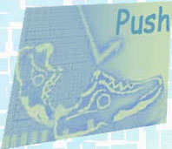
The road to becoming an elite athlete takes a lot of hard work, dedication, and often times, a dose of inspiration. AthleteBiz

Miranda Melville: My Inspiration
Inspiration is not something that can easily be found at times. As an athlete inspiration can come in many different forms. Sometimes you need the inspiration to just relax and be calm with training and indulging in life. When receiving the task to write about a particular athlete that has motivated me to become the athlete I am today, well I felt a bit stuck. I never had a big name athlete that I followed. Perhaps that is a bit weird, so I took the time to reflect on whom around me keeps me enthusiastic about training and competing. After much thought, I realized the athletes who inspired me most are the ones I have surrounded myself with everyday.

Starting in high school, it did not matter what grade, the girls I ran with every day kept me motivated on and off the track. Being on a team you make connections that can last a lifetime. Whether the girls were hurting from shin splints, or feeling overwhelmed by homework, we were all there for one another. The basic of camaraderie on the track started there. These girls were the ones going to state championships, they were the ones winning the meets, and I wanted to be like them. I wanted to be successful like them. As upperclassmen were going on to run in college and get scholarships, I became motivated to want to do the same.
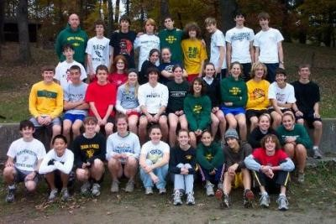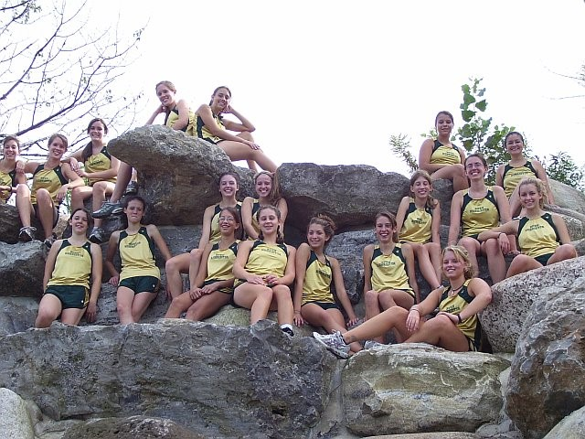

In great thanks to those girls from high school, I went on to compete and be part of a new team throughout college. Although the faces may have changed, the growth of new relationships did not. Again, an assortment of extremely dedicated and strong women surrounded me. There were many days where we may have wanted to quit, and no matter what decision was made, we always knew we had the support of one another. The experiences of being with my college teammates are some of the best of my life so far.
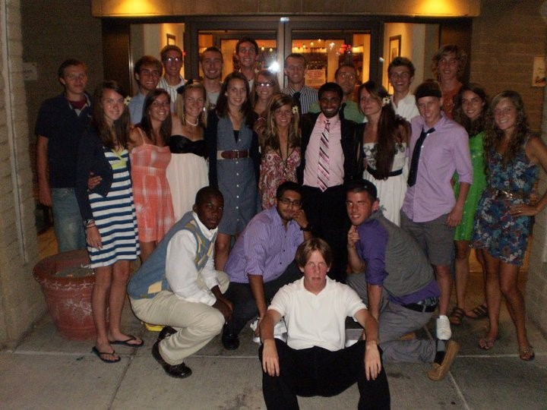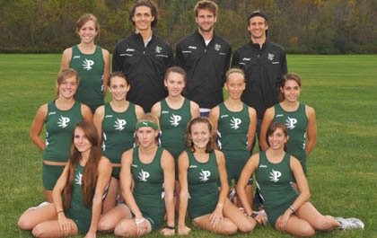

My post collegiate days brought me to a new level of competition, and a new level of inspiration. My teammates and training partners always keep me focused and helped create an even stronger athlete within myself. My current teammates have been there for me at some of my weakest moments, and have continued to fill my life with great memories of adventures together all over the world. From some of my worst races to some of my best, the groups of friends I have to train and talk with now have aided me in keeping a level head.
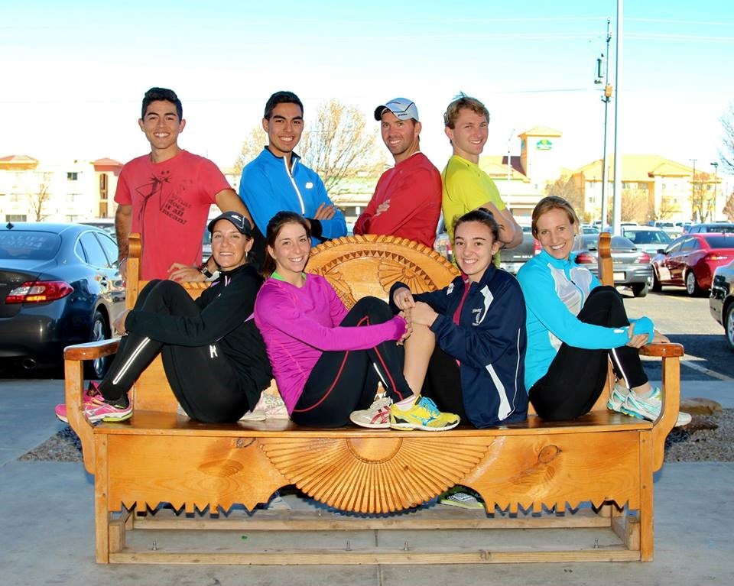

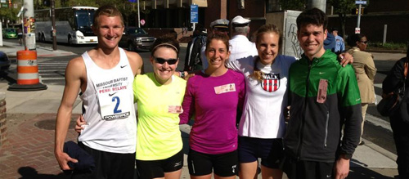
www.mirandaracewalks.com

Reference: 5/21/2014, http://www.athletebiz.us/pages/who-inspired-you, AthleteBiz website

