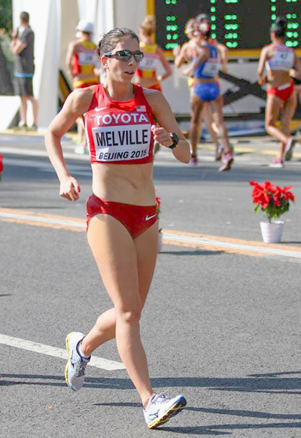 | Rochester’s Miranda Melville finishes in 26th at World Championships Race Walk  Immediate Release  C.Melville, 585-259-8015  manager@mirandaracewalks.com
(8/29/2015, Rush, NY) Rochester NY’s Miranda Melville finished 26th in Friday's women's 20-kilometer race walk (12.4 miles) at the IAAF World Championships in Beijing, China.
Miranda, who went to R-H, finished in: 1:35:19, placing #26th – her highest placement ever at a world event, and 3rd Fastest American at the World Championships.
Melville has 8 national championships including the 2015 USA National Outdoor Champion in the 20-kilometer race walk. Miranda-Race-Walks.com
#####
For more information see MirandaRaceWalks.com or Miranda-Race-Walks.com. For a Skype or telephone interview contact Miranda Melville at 585-313-2127

