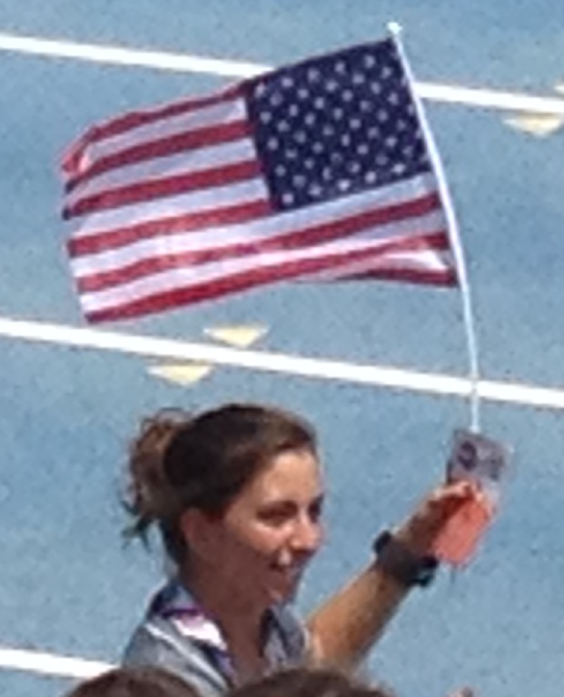 | Taking her victory lap at Outdoor Nationals -- -- Miranda Melville will round out the trio of USA race walkers going to World Championships in Moscow Russia in August 2013. Congratulations to Miranda and Coach Tim Seaman on her first World Championship team selection.

Race Walker Melville's 1st World Championship Team Selection

(Des Moines Iowa, June 22, 2013) Miranda Melville of Rush New York will round out the trio of USA race walkers going to the World Championships Games in Moscow Russia this summer.

Melville said, "I am so excited to be part of Team USA and grateful for the chance to compete at the World Championship Games. It was a very hot and humid race today and my goal was to finish the best I could under these conditions. The top three finishers worked well together and supported each other, which is going to make for a great team and I look forward to racing with them in Russia in August."

#####

