Miranda Melville Takes Home 4th National Race Walk Championship sets New Meet Record at RIT Upstate Holiday Classic

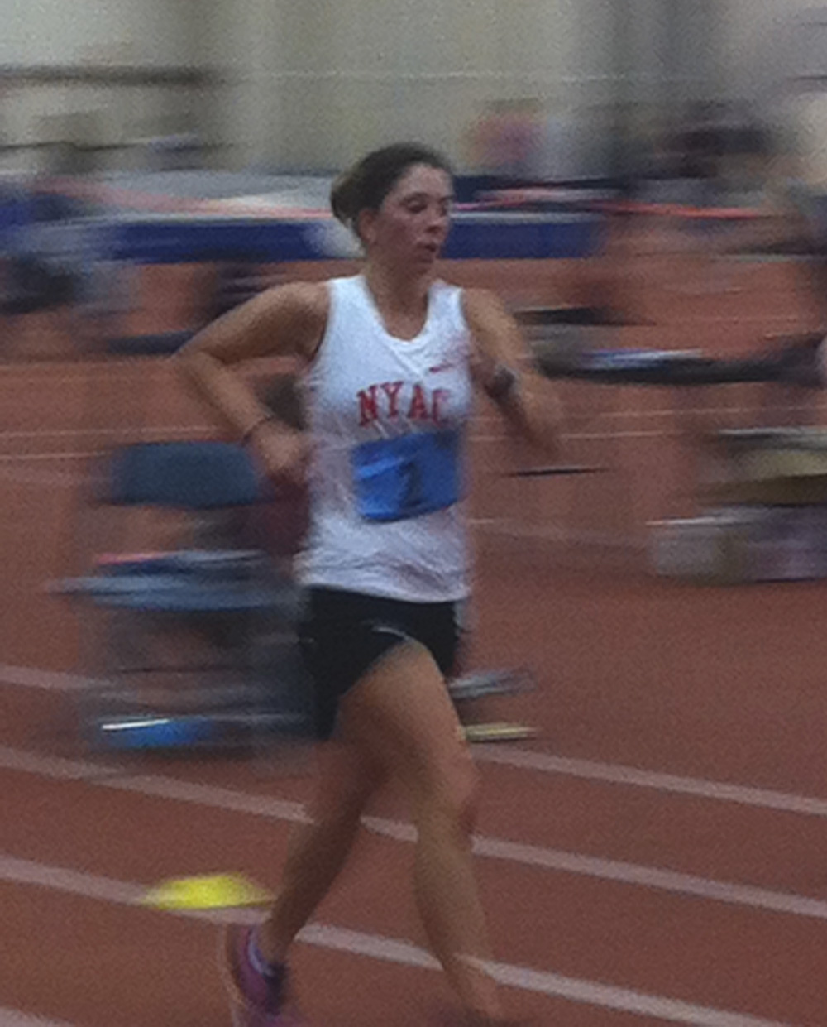
photos by c. melville - Miranda Melville at Upstate Holiday Classic, RIT Gordon Field House, 12/28/13

For Immediate Release

(Rochester, NY) On Saturday December 28th, 2013, Rush-Henrietta graduate Miranda Melville of the New York Athletic Club, won the women’s USATF 5K National Race Walk Championship at the Upstate Holiday Classic held at Rochester Institute of Technology’s Gordon Field House.

In Addition, Melville’s winning time of 22:40.03 qualified her for the USATF Indoor National Championships in Albuquerque NM this February, and set a new meet record previously held by Erin Talcott (23:58.16) of Owego, NY.

This is the 4th women’s National Championship for Melville who competed for the USA Track and Field World Championship team in Moscow Russia (2013), is a 2X, 15K National Race Walk Champion (2012, 2013), National 10K Race Walk Junior Champion (2008), and Silver medallist at the 2012 20K Race Walk Olympic Trials. Miranda is also a 2013 grant recipient from the Women’s Sports Foundation and the Rochester Amateur Athletic Federation.
#####

(Melville also holds the women’s 3000m Race Walk record for the Upstate Holiday Classic meet event with a 13:16.19).
Contact: manager@mirandaracewalks.com 585-259-8015
www.mirandaracewalks.com

