Notable Season Continues as Melville Earns 7th USA National Title
For Immediate Release
Contact: C. Melville, 585-259-8015
manager@mirandaracewalks.com
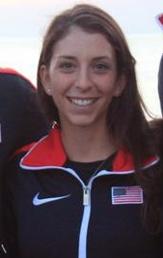 | (05/19/2015, Rush NY) Continuing an impressive season Miranda Melville, for the 4th consecutive year, has won the USATF 15K senior women’s National Race Walking Championships in Riverside California. Her win came just 1 week after she helped Team USA turn in a podium finish at the Pan American Race Walking Cup in Arica, Chile.  This is Miranda’s 7th National Title. She said, “this season has been a great experience and will hopefully make us all stronger athletes and competitors in the months to come.”  Next on the itinerary for the Women’s Sports Foundation and Rochester Amateur Athletic Federation grant recipient, is a June 28th, 20K race in Eugene OR at USA Track & Field National Championships.  The USATF National Championships will serve as the selection event for the last two big races of the season, 2 coveted spots at the Pan Am Games on July 19th in Toronto Canada, and 3 spots on the IAAF World Championships team in Beijing China, August 22-30 2015.
Robyn Stevens, Erin Gray, Miranda Melville (USA) & Rachel Seaman (Canada), at USATF 15K senior women’s National Race Walking Championships in Riverside California
#####

