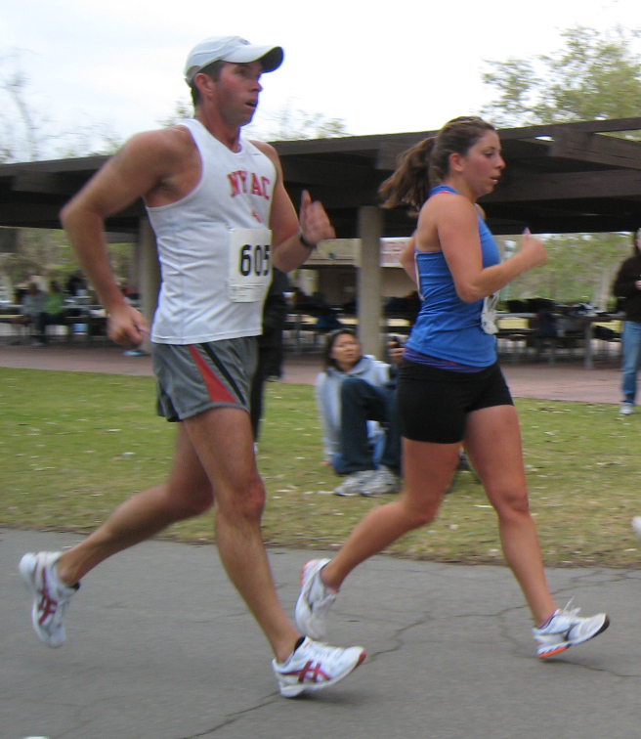
2x Olympian and Coach Tim Seaman and Miranda Melville in Huntington Beach CA.

Miranda Melville is World Cup Bound

(Rush, NY, May3rd, 2012) Local Race walker Miranda Melville has been invited to be part of the United States Race Walking team that will travel to Saransk Russia for the prestigious IAAF World Race Walking Cup on the 12-13th of May.

She has represented the USA in two previous World Cups, 2008 in Cheboksary Russia and 2010 in Chihuahua Mexico.

Coach Tim Seaman said, "I am very excited to see Miranda compete in Russia. Her training has been going very well, and the World Cup will be the start of our Peak phase of training, culminating in the 2012 Olympic Trials in the world famous Hayward Field, in Eugene, Oregon."

Melville had a terrific season opener in March when she obtained the Olympic B standard with 1:37:08 at the St Patrick’s Day Classic in Huntington Beach California, a PR by almost a minute.

“I look forward to going and having a chance to race well”, Melville said, “ I know when I get there, I will be with the best from around the world and it will be very completive, that can only help you”.

Miranda is a 2012 recipient of the Greater Rochester Amateur Athletic Federation (GRAAF), travel and training fund grant and North American Racewalking Institute (NARI) Training Fund grant.

Athletes from 67 Member Federations, a record number of countries, will participate at the World Cup in Saransk with many athletes using the opportunity to test competitive progress against top international competition.
#####.

.For Immediate Release, CONTACT: C. Melville, 585-259-8015, manager@mirandaracewalks.com

