Melville  Makes World Cup Team is 4th Fastest American Woman Ever  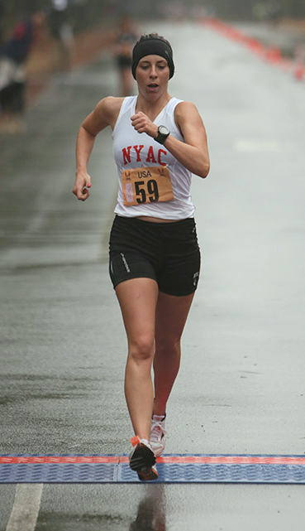  Finishing 20K WCT  Photo courtesy of Racewalk.com | (3/30/14, Manchester, NJ), Miranda Melville (Rush, NY/New York AC) clocked 1:33:10 to better her previous mark by almost two minutes and put in the fourth-fastest time in U.S. history as over 50 race walkers from across the country competed at the USATF World Race Walk Cup 20K trials this weekend.  The athletes raced for a spot on the USA women’s national team and a trip to battle against the world’s top athletes in this year’s IAAF World Race Walking Cup in Taicang, China, May 3-4.  This is her 4th World Cup Team, and 3rd time Melville has secured a spot on the senior American National Team.  “I am so excited that Miranda has qualified to compete in the World Cup, and that she had almost a 2 minute PR,” said Coach Tim Seaman. “She has moved up to now be the 4th fastest American woman ever, I couldn't be happier with her progress”.  The China-bound team will be spearheaded by 2012 Olympian and American record holder Maria Michta (Nesconset, N.Y.) and rounded out by Susan Randall (Beavercreek, Ohio/Miami Valley TC), Katie Burnett (Rochester, N.Y.), and Erin Taylor-Talcott (Owego, NY/Shore AC).
Miranda said, “I am excited to best my personal record in the 20K by almost 2 minutes. It only leaves me hungrier for future races and even faster times. I am elated to be going to the World Cup and to experience another elite race as a member of Team USA.”
#####

Contact: Manager@mirandaracealks.com, 585-259-8015.
Skype interviews can be arranged with Miranda and/or her Coach.

