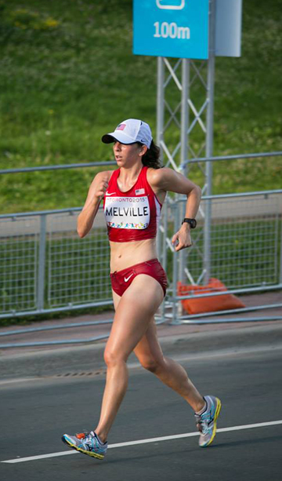 | Gritty Performance  At Pan Am by R-H  USA Nat’l Race Walk Champ  Miranda Melville  For Immediate Release:  Contact: C. Melville, 585-259-8015, Miranda Melville, 585-313-2127, manager@mirandaracewalks.com  Photo - Kai Christensen

(Toronto Canada, July 19, 2015)
Fresh from a first place finish 3 weeks ago at USATF Outdoor Championships elite race walker Miranda Melville turned in a gritty performance at the Pan Am Games 20km Race Walk competition in Toronto Canada for a strong 10th place finish. The hot and very humid conditions made for a demanding 12.4-mile race but the USA National Champion was poised, prepared, and able to manage both the heat and the stress competition at this level brings.

Stay tuned for Melville’s last race of this pre-Olympic season, August 28th, in Beijing China, where the USA Champion will compete on the world stage.

2X Olympian and Coach Tim Seaman said, “Miranda should be very proud of her 10th place finish, she had a solid race at Pan Am Games and is ready for the IAAF World Championships on August 28th in Beijing China”.
#####

