Melville Nails Women's 5000m Leading up to Outdoors Championships

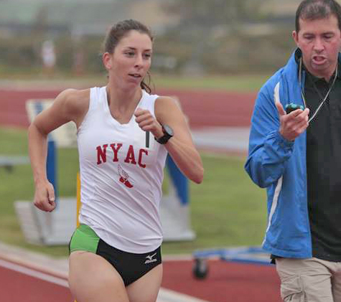  Melville & Coach Seaman (Photo by Eduardo Corvera) | For Immediate Release:  Contact: C. Melville, 585-259-8015  manager@mirandaracewalks.com  (US Olympic Training Center San Diego, CA., June 13, 2015)  Miranda Melville had a big race Saturday at the 2015 San Diego Imperial USATF Western Championships held at the US Olympic Training Center in Chula Vista/San Diego, CA.  Her time of 21:41.99 is one of the best 5000m Race Walking times in the USA in a very long time.

While not the Olympic 20k distance, the 5000m acts as a good fitness benchmark to monitor an athletes performance and goal accomplishment during the season.

Olympic Coach Tim Seaman said, “Miranda did a great job this morning, walking the whole race by herself. She is coming into form at the perfect part of the year, just as planned. I am looking forward to her remaining summer races.”

Miranda’s next race will be on June 28th at the USATF Outdoor Track & Field Championships in Eugene Oregon. That race, with a west coast 7:00am start, is expected to be televised online at USATF.TV. Successful athletes will earn spots on the IAAF August 2015 World Championships Team for Beijing China and on the Pan Am Games team set for July in Toronto Canada.

For more information see MirandaRaceWalks.com. For Skype or telephone interviews contact Miranda Melville at 585-313-2127

#####

