Melville Announces Olympian Tim Seaman as New Race Walk Coach

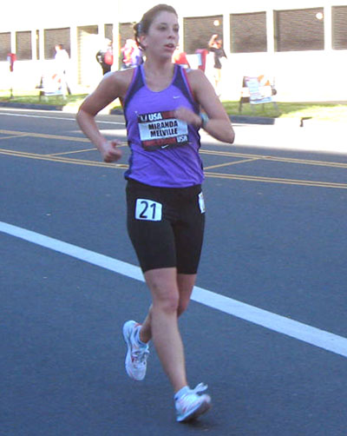  2011  USATF Nationals | Contact:  manager@mirandaracewalks.com

(Rush, NY, November, 2011) Rush NY native, and USA Track and Field National Team athlete, Miranda Melville has announced she’ll be training in San Diego California for the 2012 Olympic trials under the tutelage of Race Walk Olympian and Coach, Tim Seaman.

Coach Seaman said, “I am excited to have Miranda as part of our team. She adds a tremendous amount of new energy to the group and she has already made a huge impact upon all of us. Her enthusiasm is contagious and I know that there is a ton of potential in her. I am looking for her to make a big shock on the US race walking scene.”

Miranda Melville, who was disqualified from her very first race for breaking form, was a USA Junior National Champion and competed on several Junior USA teams before moving up to the senior ranks. This year at the USA Track and Field Championships in Eugene Oregon she finished 4th with a huge PR of 1:38:01, an agonizing one-second off of the Olympic B standard.

“I am happy to have the opportunity to be in this year-around training climate and looking forward to seeing what I can do using Coach Seaman’s training philosophy”, Melville said.

Tim Seaman is a 2x Olympian who has 10 American records and 43 National Championships to his resume. Tim also co-authored four books with Jeff Salvage, including the highly popular Race Walk Faster by Training Smarter, in which he lays out his successful philosophy of training.

Melville previously trained with Coach Mike DeWitt and decided to make the coaching switch after graduating from the University of Wisconsin-Parkside (UW-P) in May.

Mirandaracewalks.com
Champions-international.blogspot.com

