First American Woman Since 2000 to Walk 10k under 45:30  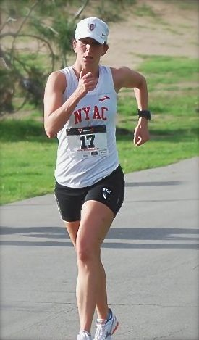 | Contact: 585-259-8015  manager@mirandaracewalks.com  (Huntington Beach, California 3/9/14) — Rush-Henrietta graduate and elite race walker Miranda Melville from Rush NY was top female finisher with a 45:27 at Sunday's USATF 2014 Southern Cal 10K Race Walk Championship. "I believe this makes her the first American woman to walk under a 45:30 in a 10k RW since approximately 2000*", said two-time Olympian and Coach Tim Seaman. He added, "this was a personal best time and best placement for Miranda at the 10K distance".  Miranda said, "It was great weather with a good course, and it was the perfect way to let me know what kind of shape I am in for the Olympic 20km distance going into World Cup trials at the end of March.  Coach Tim Seaman added, "Miranda is having a great season and her 10 km time shows we are on the right track for some exciting fast times in New Jersey and China”.  Melville trains with Champions International and is a member of the New York Athletic Club. Her next race will be the World Cup trials, March 30 in Manchester, N.J. That event will determine the United States team at the race walking World Cup, May 3-4 in Taicang, China.
During a race Miranda can do a mile in under 7 minutes, hold around 7:30/mile for a half marathon, and can walk over 227 steps/minute using a very technical and near flawless technique.

Race walking can have much the same cardiovascular benefits of running but with less impact on joints. Race walkers have fewer injuries and can get their heart rates as high as running. Race Walking is part of Olympic track and field and is gaining popularity because it does not require expensive equipment and nearly anyone can participate, from beginning exercisers to Olympic caliber athletes. Race walking will give you a much better workout than 'regular' walking and it is much easier on your body than jogging or running.

*Record Reference: <http://www.usatf.org/usatf/files/f4/f4fca8e1-d50e-47f8-9774-4fcd198ac9b7.pdf>

