For Immediate Release
Contact: manager@mirandaracewalks.com, 585 533 2202

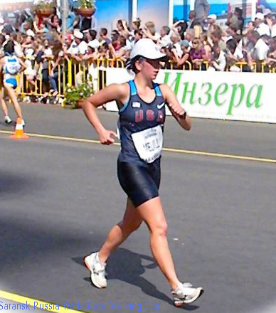

Rush NY’s Miranda Melville Top USA Senior Team Finisher at IAAF World Race Walking Cup in Russia

(May 13, 2012, Saransk Russia) Miranda Melville from Rush, New York walked a 1:39:14 today at the IAAF World Race Walking Cup in Saransk, Russia. She was the top 20K race walk finisher for the senior USA Team.

Conditions were hot (90 degrees) and windy on the road course for Melville as she battled to finished 49th out of 106 in the world class event.

Previously this season Melville walked a 1:37:08, a PR by almost a minute and a super season opener that bested the Olympic “B” standard. She has also qualified for the USATF Olympic Trials to be held In Eugene Oregon on July 1st.

Coach Tim Seaman said, "I am very excited to see Miranda compete in Russia. Her training has been going very well, and the World Cup will be the start of our Peak phase of training, culminating in the 2012 Olympic Trials in the world famous Hayward Field, in Eugene, Oregon."

Athletes from 62 Member Federations participated at the 2012 World Cup in Saransk, with many athletes using the opportunity to test competitive progress against top international competition.
(more)
Melville has represented the USA in two previous World Cups, as a junior in 2008 in Cheboksary Russia and 2010 in Chihuahua Mexico.

Official results.
<http://www.iaaf.org/mini/wrw12/Results/Results.aspx?/eventCode=4666/sex=W/discCode=20KR/combCode=hash/roundCode=f/results.html#det>

**** ****

