Local Athlete Mounts Breathtaking Battle for Gold at
Olympic Trials 20K Race Walk

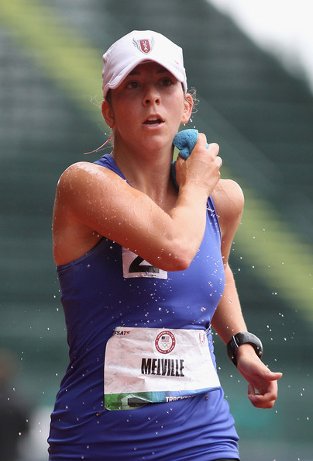  Miranda Melville cools down during 20k Olympic Trials  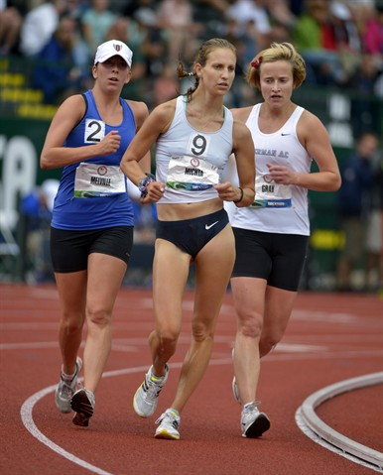  Melville’s charge surprises, Maria Mitchta & Erin Gray | Contact: manager@mirandaracewalks.com  (July 1, 2012, Eugene Oregon) Miranda Melville mounted a furious challenge at the USATF 2012 20K Race Walk Olympic Trials in Eugene Oregon to finish with a personal best 1:34:56 for silver, missing a trip to the London Games by only 3 seconds.  The early morning crowd at historic Hayward Field were on their feet cheering as seemingly out of nowhere, Melville of Rush, N.Y. moved from fifth nearly three quarters of a lap back, to fourth, to third, then to second as she challenge national champion Maria Mitchta of Long Island.  Melville said of her chase. “I knew I had to race smart and push. I wasn’t going to give up on this easily, “I was on the hunt, and I was not going to slow down. I had to go after it.”  Sensing a race to the finish, the announcer reminded the crowd that judges could disqualify race walkers in the last 100 meters without the usual two warnings. Michta pulled away only on the final straight away to win with a 1:34:53.  All of the top three finishers met the Olympic “B” standard, but none of them surpassed the “A” standard of 1 hour 33 minutes 30 seconds. As a result, only first place Mitchta qualified for the Olympic Team.  #####  Phone or Skype interviews gladly arranged,  Call: 585 259 8015 or 585 313 2127

See Melville’s Runnerspace.com post-race video interview – USA 20k Olympic Trials,
<http://www.runnerspace.com/eprofile.php?do=videos&video_id=73165&event_id=49>

