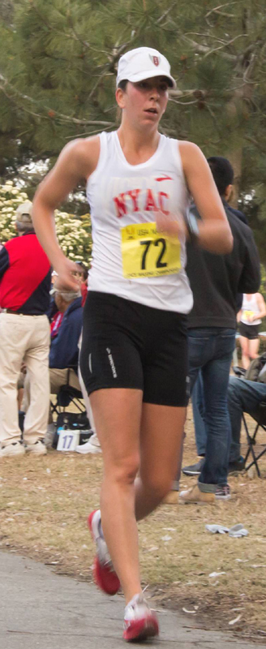  Photos by Steve Shoemaker | 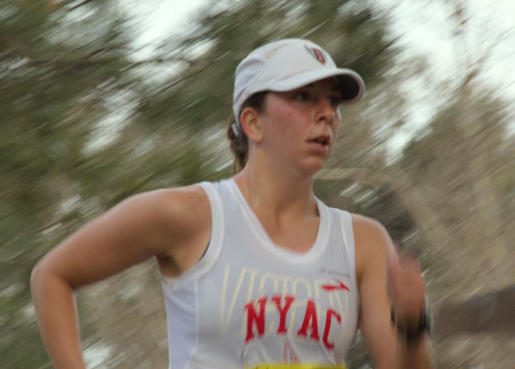
Melville Captures
3rd National Race Walk Title

For Immediate Release manager@mirandaracewalks.com
585-259-8015
(05/19/2013, Rush NY) For the 2nd consecutive year, and third of her career, NYAC’s Miranda Melville has won the USATF 15K senior women’s National Race Walk (RW) Championship in Riverside California. Her win with a 1:11.40 was a huge improvement over last year’s time of 1:17.55 and came just two weeks after a 46:09 2nd place finish, at the USA 10,000m racewalk championships in Farmingville, NY.
Melville said, “it’s a real confidence booster to see improvement. This was a truly fun race, the crowd was full of enthusiasm and it was great to have someone like Erin Grey to race with. Nothing beats having someone to be excited with you and to work with through a race.”
Next on the itinerary for the 2013 Women’s Sports Foundation and Rochester Amateur Athletic Federation grant recipient, is a June 22nd 20K race in Des Moines IA at the USA Outdoor Track & Field Championships. The 2013 Championships will serve as the selection event for the 3 coveted spots on Team USA at the IAAF World Championships August 10 - August 18 in Moscow, Russia.
(In 2008 Melville won the Junior National Race Walk Championship title in Columbus Ohio)
#####

Photo by Steve Shoemaker | 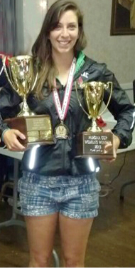  2013, 15K National Champion & Tony Perona Cup Recipient
2013 - Melville Captures 3rd National Race Walk Title!
NYAC's Miranda Melville has won her 2nd consecutive senior women’s National Race Walk (RW) Championship title, the third of her career, with a 15K time of 1:11.40 at 15k RW National Championships in Riverside California on May 12th. She was also named the Tony Perona Cup recipent and can take pride in being the first woman to finish first overall in the 25 year history of that race.
Miranda is currently rated #2 in the US. In 2012, at the 20K Race Walk Olympic Trials in Eugene Oregon, she finish with a personal best 1:34:56 for silver missing a trip to the London Olympic games by only 3 seconds.
She is a Junior National champion, has competed on the international stage in Russia, Mexico and Canada for Team USA, and the USA World Cup Teams. She is a NYS Empire State Games Champion, Women's Sports Foundation grant recipient, Rochester Amateur Athletic Federation grant reciptient and scholar athlete.
At the 2013 USA Track & Field Outdoor Championships in Des Moines IA, she was selected to Team USA to compeat at the 2013 IAAF World Championships in Moscow, Russia.

