14 Second PR For Melville at Indoor Nationals

Miranda Melville at USATF 2014 Indoor Nationals  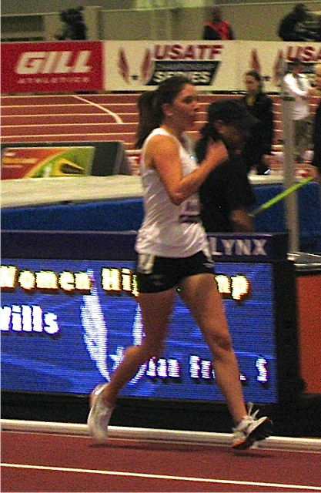  www.MirandaRaceWalks.com | 2/23/14 ALBUQUERQUE, N.M. — Rush-Henrietta graduate and elite race walker Miranda Melville finished second at last Sunday's USATF 2014 Indoor National Championships with a 12:59. This was a personal best time for her in the 3,000-meter Race Walk and beat last year’s winner’s time, and was her best placement at the Indoor Nationals, (she finished third in 2013).  Melville trains with 2x Olympian and Coach Tim Seaman and is a member of the New York Athletic Club.  Her next race will be the World Cup trials, March 30 in Whiting, N.J. That event will determine the United States team at the race walking World Cup, May 3-4 in Taichang, China.  Contact: manager@mirandaracewalks.com

