Democrat and Chronicle 04/02/2014 Page : D02

SPORTS TICKER

Track and field
Rush-Henrietta grad
qualifies for world
championships: Rush-
Henrietta graduate Miranda
Melville recorded
the fourth-fastest racewalking
time in U.S. history
at the USATF World
Race Walk Cup 20K trials
on March 30 in Manchester,
N.J.
Melville was the second
American to finish
and qualified for the
IAAF World Race Walking
Cup, held May 3-4 in
Taicang, China.
It is her fourth World
Cup team.
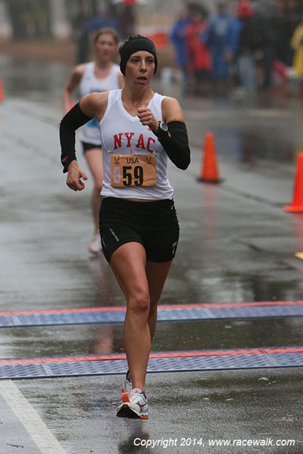
picture added

