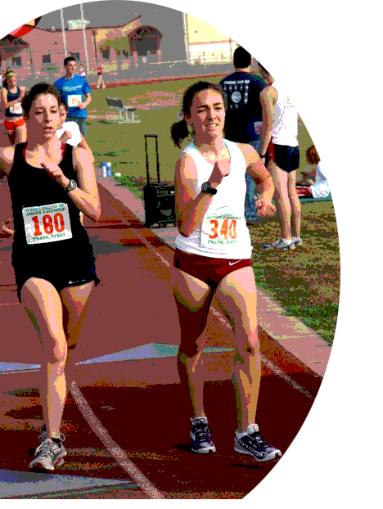  Melville (Rush, NY), Josephs (Garden City, NY) | For Immediate Release

Everything Is Bigger In Texas, Even Walking!

Melville Starts New Year on Pace As Race Walk Season Takes Shape

(Pharr Texas, January 1th, 2011) Miranda Melville walked a solid personal best time of 24:02 at the New Years Day 5K competition billed as TEXAS’s LARGEST 5K RACEWALK. The top female American finisher took 2nd place 40 seconds faster than her previous qualifying time of 24:42.

Canada's 2X National Race Walk Champion, Rachel Seaman, was the overall winner with a time of 22:48 and third went to Chihuahua, Mexico’s Nirvana Zalba with a 24:24.

Just a few steps behind was R.I.T. student Rachel Zoyhoski of Henrietta, NY, who finished with an impressive 26:56.

Melville, a Rush NY native and member of the USATF Niagara Association, was attending an Olympic Development Camp with many of the current crop of elite racewalkers. The weeklong workshop focused on methods honed by two time race walk Olympian, Tim Seaman (Race Walk Faster by Training Smarter), that included twice a-day workouts of distance, rhythm, technique and recovery with 5km repeats and video analysis.

"It felt great to be the top American finisher in the Texas 5K," Melville said. “This training camp was challenging and a valuable learning experience for me as I prepare to compete in the Pan Am Trials in February and Outdoor Nationals in June”.

A senior and honor student at Wisconsin-Parkside, Melville is currently ranked 6th in the USATF Race Walk by Track & Field News Magazine. For more information on Miranda and Racewalking go to http://www.mirandaracewalks.com/

#####

