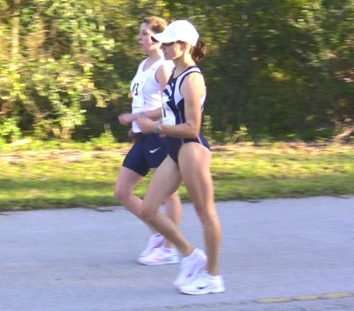 Miranda Melville & Solomiya Login (photo by Dave McGovern) | For Immediate Release  Contact:  carla@rpa.net
Melville Captures Spot on Pan American Cup Race Walk Team
(2/13/2011, Coconut Creek, Florida) Miranda Melville of Rush NY, bettered her previous 20K (12.4 mile) mark by almost 4 minutes with a 1:41:39 3rd place finish at yesterdays USATF Pan American Cup Race Walk Trials at Tradewinds Park in Coconut Creek, Florida, assuring her a spot on the US Pan American Race Walk Cup team.
Melville, a senior at the University of Wisconsin-Parkside, and member of the USATF Niagara Association said, “I corrected some short arm motion early in the race and extended my stride to pull away from Solomiya Logan. My turnover slowed with a bout of cramping at about the 12k mark and Logan caught up. Once that happened, I stayed with her and then really kicked at the end to pull away”.
While the final teams composition will depend on collegiate commitments, Maria Mitcha, post graduate student at Mt. Sinai School of Medicine who finished first with a 1:36:30, besting the Olympic “B” standard, Erin Gray of the Bowerman Athletic Club in Oregon, and Solomiya Login of Southeastern Pennsylvania's Athletics Club will round out the USA squad bound for Medellin, Columbia at the end of March.
Dan Seriani, from Rochester, NY, finished 4th with a big personal best time of 1:32:57 to earn a spot on the men’s squad.
Never Heard of Racewalking? Race walking is about athletes’ endurance and determination. It’s been an Olympic event for more than a century. In Race Walking the “walk” is purposeful, following the stringent rules of the sport: One foot must be on the ground at all times, the lead leg must be kept straight (no bent knees).
When racing shoulders are held straight and hands are held low and close to hips. The racer appears to have a bit of swivel caused by the heal-to-toe action necessitated by the rules.
Judges watch the racers form closely along the entire course looking for a bent knee or lifted foot. The judges can, and do, issue violations. Like baseball, three of them and the race walker is out of the race.
To learn more about Race Walking visit Mirandaracewalks.com.

#####

