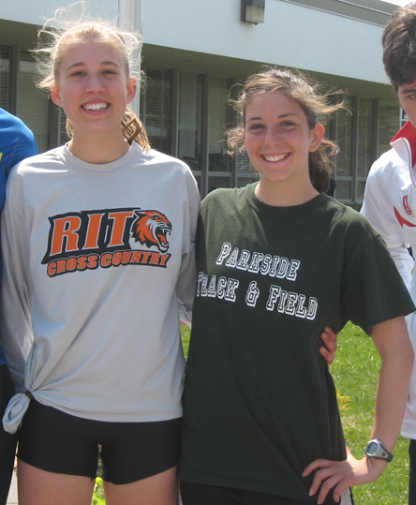  Zoyhofski and Melville | For Immediate Release

Western Region Dominates Racewalk at 2010 Empire State Games

(July 24, 2010, Niagara Falls, NY) 5 metals total were earned so far by Western Region athletes in the Empire State Games Racewalk this weekend.

10K women Gold – Miranda Melville of Rush, NY
5K women Gold - Rachel Zoyhofski of Pittsford, NY
5K men Gold - Allen James of Sanborn, NY
5k masters men Gold Leonard Borzynski, Amherst NY
5K women Bronze - Chelsea Conway of Rochester, NY

Anyone brushing off these races because of that "w" word might want to take a closer look.
A technically demanding event, according to USATF rules, a walker must always have one foot in contact with the ground, and the advancing leg must be straight –– with no bent knee — until the leg is completely vertical to the ground. The arms are pumped low by the hips for maximum forward propulsion.
The result is a fast walk with attitude!

All judging is done by the eye of the judge and no outside technology is used in making judging decisions.”

Race walking has been an Olympic sport since 1906 and is great exercise.
For more information visit mirandaracewalks.com

#####

