-- 2013 UPDATES --

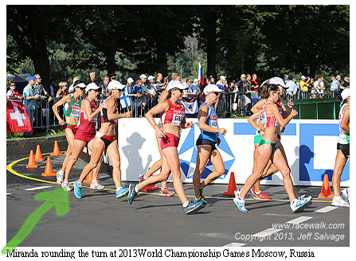

World Championships Photo by Jeff Salvage

-Selected for USA World Team 2013 World Race Walk Championships.

- 2013 USA 15K National Race Walk Champ & Tony Perona Cup Recipient.

-Named USATF San Diego Association - Race Walker of the Year.

